**Data Transformation – Excel Process**

## Convert Time

* 1. Insert a column to the right of *Time* and name *Converted_Time*
  2. Insert the formula from 1.2.1 into the *Converted_Time* column and fill down
     1. **=B2/86400** – Converts the time column into seconds. 86400 is the number of seconds in a day.

1.2.2 Change *Converted_Time* column format to “time” (option 4)

## Create Session Id

* 1. Insert a column to the right of *Status* and name *Session_Count*
  2. Insert the formula from 2.2.1 into the *Session_Count* column and fill down
     1. **=COUNTIF($G$2:$G2,G2)** – Begins counting the occurrences of behaviours from the *Behaviour* column, marking each unique instance of the behaviour as 1.

* 1. Insert a column to the right of *Session_Count* and name *Session_Behaviour_Count*
  2. Insert the formula from 2.4.1 into the *Session_Behaviour_Count* and fill down
     1. **=CONCAT(G2, " ",I2)** –Joins the behaviour and the session count field

* 1. Insert a column to the right of *Session_Behaviour_Count* and name *Session_ID*
     1. **=CONCAT(LEFT(L2,1),RIGHT(L2,1), ",-",UPPER(LEFT(G2,5)),CEILING(I2/2,1))** – Creates a unique ID for each unique behaviour. This is a combination of the participant’s code and the count of each behaviour. Each behaviour has a stop-and-start value. These are considered in pairs as one behaviour.

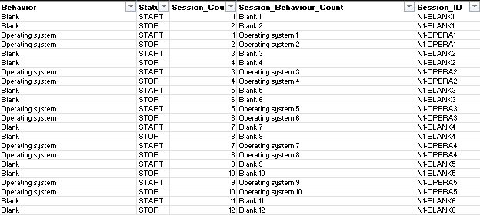

## Create Session Time

* 1. Insert a column to the right of *Session_ID* and name *Session_Time*
  2. Insert the formula from 2.7.1 into the *Session_Time* and fill down
     1. **=IF(H2= "START",XLOOKUP(G2,G3:G$281,B3:B$281)-B2, "")** – Finds the next occurring instance of the behaviour by using excel’s lookup function then calculates the total seconds for that behaviour using the *Time* column.

## Convert Recording Dates and Times

* 1. Insert a column to the right of *Recording_Time* and name *Recording_Time_Conversion*
  2. Insert the formula from 4.2.1 into the *Recording_Time_Conversion* and fill down
     1. **=TIMEVALUE(TEXT(Q2, "hh:mm"))** – Converts the time from recording time into time format with seconds value

4.2.2 Change *Recording_Time_Conversion* column format to “time” (option 1)

* 1. Insert a column to the right of *device* and name *Recording_Day*
  2. Insert the formula from 4.4.1 into the *Recording_Day* column and fill down
     1. **=LEFT(P1,3)** – Splits the full recording day field into the day and date

## Create Recording Running Time

* 1. Insert a column to the right of *Recording_Time_Conversion* and name *Recording_Running_Time*
  2. Insert the formula from 5.2.1 into the *Recording_Running_Time* column and fill down
     1. **=R2+C2** – Adds the converted time in seconds to the converted recording time to create a running recording time that can be used for timelines.

## Clean-Up

* 1. Rename column A header as *Row_Number*
  2. Change *Row_Number* column format to number with 0 decimal points
  3. Convert *Time* column to number
  4. Convert *Total_length* to number
  5. Convert *Recording_Date* to date (option 3)
  6. Convert *FPS* to number
  7. Change column *Media file path* to *Media_file_path*
  8. Change column *Media file path* to *Media_File_Path*
  9. Change column *Total length* to *Total_Length*

1. Remove column *Recording_Duration* (this is represented through total_length)